**Instruction To Execute the Source Code**

**-Group 13**

**Requirements’:**

1. Vs Code (Text Editor)
2. Install Python
3. Install Django Extension

**How To Start the Web Application: -**

1. Open the Source Code folder named “Group 13” in Vs code.



1. Start a new terminal in Vs code then run the command “python manage.py runserver” in the terminal.



1. Upon executing the above command we get the server link similar to ” <http://127.0.0.1:8000> “ .

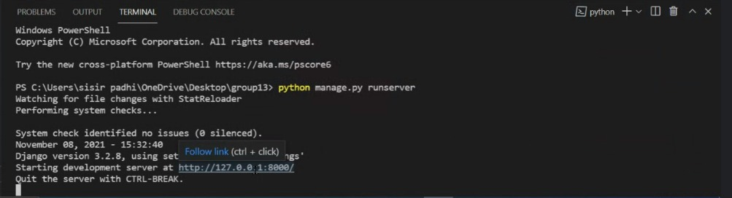

1. Follow the link in your favorite browser to get to the main page.

We are all set to go….